Zoom Advanced Instructions
The following information details how to set up meetings using the website and additional tools that you can incorporate in your synchronous classes to keep students who are attending virtually engaged in active learning.

Logging in to the Zoom website
Go to http://unl.zoom.us and click on Login. Scheduling a meeting will look exactly the same as it does when you log in through Canvas. If you aren’t sure about some of the settings, please refer to the Zoom Basic Instructions document.

Meeting options
There are a whole host of meeting options that can only be accessed through the website. If there is a tool you want to use but you aren’t seeing it in your meeting, log in to the zoom website and check the settings. Please note that if you change a setting (like turning on a tool), you may need to end any open meetings or even re-start Zoom for some features.
These options are broken down into sections (please note that not all options for each section are listed below; the most commonly used or requested settings are listed to give you an idea of where to look for a particular setting):
- Security (waiting room, passwords, authentication)
- Schedule Meeting (same options as scheduling a meeting, but this sets the default for meetings you create)
- In Meeting – Basic (chat, notifications, polling, meeting controls, screen sharing, annotation, reactions, participant options)
- In Meeting – Advanced (breakout rooms, remote support, closed captioning, HD Video, virtual background, meeting invitation plugins, join from browser)
- Email notifications (when you want to receive emails, e.g. when a recording for a meeting you hosted is available, when attendees join before you)
- Other (iOS task switcher, schedule privilege)

Meeting Tools
Below are some of the most commonly used meeting tools. In this section, we’ve provided some strategies for using each tool as well as links to tutorials and additional support.

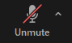
Audio Tools (Mute/Unmute)
This one seems obvious, but it is also a little misleading. The Mute/Unmute button shown to the left only adjusts your microphone. The strategies for managing the microphones for participants, which can be set using the website or from within the meeting in the Participants panel:
- Allow Participants to Unmute Themselves (go to Participants > More Options (the three dots in the gray button at the bottom of the panel) > Allow Participants to Unmute Themselves): You can set the meeting so that students can’t unmute themselves, allowing the speaker to present without interruptions. This is probably most useful when you have a guest speaker or students are giving live presentations.
- Mute Participants upon Entry (go to Participants > More Options (the three dots in the gray button at the bottom of the panel) > Mute Participants upon Entry) will help prevent background noise from latecomers.
- Mute All (go to Participants > Mute All) is useful when several participants have unmuted or there are a large number of participants and finding the one or two open microphones would take a while, and the focus needs to be brought back to the speaker.

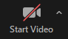
Video Best Practices
The Start/Stop Video button shown to the left, like the Mute/Unmute button, only affects your video. It is ideal for engagement to have everyone’s camera on, but with large classes especially, that can put a strain on bandwidth, so it may be necessary to ask some or all students to turn off cameras to help avoid connection issues. Here are a few other strategies and considerations for video:
- If there are bandwidth issues, have students turn off cameras (especially in high-enrollment courses).
- If students are in breakout rooms, they can turn their cameras back on to have more engagement with each other. The bandwidth required to view video for a handful of participants is much less than a to view videos for a whole class of students, so turning cameras will generally not cause a problem with connections in the breakout rooms, but they may need to turn off cameras again when returning to the main room.
- Even if cameras are off, you can keep a sense of connection with students by putting up a profile picture. You can do this through the http://unl.zoom.us web page.
- Here is a tutorial for how to customize your profile: https://support.zoom.us/hc/en-us/articles/201363203-Customizing-your-Profile

Chat
The chat function is a great way to communicate with students and for students to communicate with instructors and each other. To avoid the chat becoming a free-for-all distraction, consider how you want students to interact with you and each other. More information about Chat can be found here: https://support.zoom.us/hc/en-us/articles/203650445-In-meeting-chat
- Send resources to students through the chat: you can send links to assignments, videos, files, tools, or anything else you want them to use or have as a resource.
- Communicate clearly with students about how you’d like them to use the chat: should they hold questions until asked? Should they ask questions in chat? Can they respond to each other?
- Another way to guide how students use the chat is to set the options within the meeting settings.
  - Log into the http://unl.zoom.us web page to set the default settings through In Meeting (Basic) settings.
  - From within a meeting, you can turn off chat entirely through the Security button (you can still send messages to students, but they can’t send any messages—this can keep the chat clear of distractions but also prevents students from alerting you to any issues).
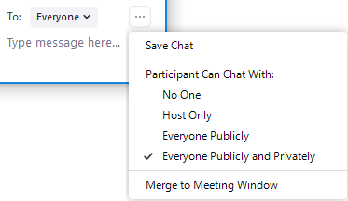
  - From within a meeting, you can limit who students can send messages to through the More Options (three dots) menu in the Chat panel (see right). Please note that to change this setting for everyone in a meeting, the “To” drop-down menu needs to say “Everyone”; if there is an individual’s name in that field instead, the change will only affect that one user.

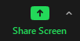
Screen Share
Screen sharing is an easy way to share materials like documents, presentations, and videos in real time. With some of the collaborative features in Zoom, screen sharing can become even more engaging and keep students learning actively.
- Note that when you start screen sharing, your meeting controls will move from the bottom of your screen to the top of your screen.
- Use the Annotation tools in Share Screen to draw attention to areas on the document. You can draw shapes, put in text boxes or stamps, or even use the spotlight tool to act as a laser pointer.
- If you are presenting in person and usually point out information you want students to focus on by using a laser pointer or standing in front of the screen, students who are attending virtually cannot see what you are pointing to. Using the Spotlight tool in the Annotation toolbar turns your mouse into a digital laser pointer, allowing all students to see what’s being pointed to.
- By default, anyone in the meeting can annotate the shared screen. You can change this setting to only allow the user who is sharing their screen to annotate by changing the default setting in your account through the http://unl.zoom.us website or within an individual meeting room through the More Options (three dots) menu on the screen share meeting controls at the top of the screen.
  - This can be a useful way to have students collaborate with each other in a breakout room, especially when paired with the Whiteboard function.
  - Encourage engagement and co-creation of knowledge and learning by having students use stamps (the check mark or the question mark stamps in particular) to indicate what information on a screen they agree with or have questions about. (This works better in smaller classes.)
- The Whiteboard function is essentially a blank space to create content digitally, just like a whiteboard in a physical classroom. Use the Annotation tools to draw, add stamps, or type into text boxes. These can be saved as an image by the user who is screen sharing.
  - Pair this with Breakout Rooms to have students work collaboratively on a problem.
  - The Whiteboard does not save automatically, so be sure to save anything you want to keep before closing it. If students are using the Whiteboard in Breakout Rooms, it is also a good idea to broadcast a message to them reminding them to save their work.
  - One limitation of this tool is that images cannot be added to the Whiteboard. To mark up an image or other document, simply share that application instead and Allow Participants to Annotate.
- More information about the Annotation tools can be found here: https://support.zoom.us/hc/en-us/articles/115005706806-Using-annotation-tools-on-a-shared-screen-or-whiteboard

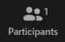
Participants Panel
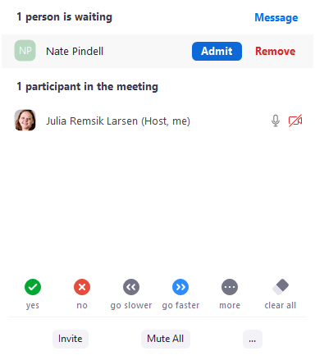
This is a deceptively powerful panel for engagement; this panel contains more than just a list of participants. From this panel, students can provide non-verbal feedback about the pace of the session, give a quick yes or no answer to a question, and indicate that they have a question by using the “raise hand” button. This feedback will appear within the Participants panel. More information about the Participants panel can be found here: https://support.zoom.us/hc/en-us/articles/115005759423-Managing-participants-in-a-meeting
- You can remove participants by hovering over their name in the panel and clicking “Remove.” Please note that you do not need to send a student to the waiting room before removing them.
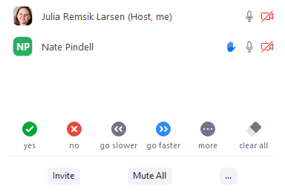
- Make use of the Yes/No (or thumbs up/thumbs down) buttons to get a quick sense of how comfortable students are feeling with the material in that moment.
- Keep an eye on the Participants panel to see who has a question. Students who have raised a hand will float to the top of the participants list, which is particularly helpful in larger courses.
- This panel also shows at a glance who has cameras on, who is muted, who is a host (or co-host), who is sharing their screen currently, and if anyone is recording.

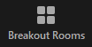
Breakout Rooms
Breakout rooms allow for small group work digitally. This is an effective substitute for in-person small group work and works well for hybrid instruction. These can be created randomly on short notice or developed with detailed membership ahead of time.
- When assigning students to breakout rooms, consider how you want to group them.
  - Consider assigning a mix of in-person students and virtual students to help support social distancing and encourage community between the two groups. This will also cut down on potential feedback from having multiple people in the same room having their microphones on at the same time.
  - For activities where the class may be split into two or three teams to discuss a topic, consider grouping virtual students only with other virtual students and in-person students together. This will work well for having larger groups of students able to discuss a topic without others overhearing the conversation, especially in activities such as a role play or debate.
- Breakout rooms are not recorded by default, but they can be recorded by one of the participants within the breakout room.
- Only hosts can set up the breakout rooms, but co-hosts, once assigned to any room, can move between rooms at will. This is especially useful in large classes with TA support.
- Students will be able to ask for help from within the rooms, so you can see who has questions and join the room to converse with smaller groups who may need additional help.
- You can send an announcement to the breakout rooms. This is a great tool to let students know how much time they have left for the activity or, if they are working on an activity that involves taking turns, to have students switch to the next person. Please note that these messages only stay up for about 10 seconds.
- Here are a few tutorials for the most commonly asked-about features of Breakout Rooms:
  - General information about setting up Breakout Rooms: https://support.zoom.us/hc/en-us/articles/206476313-Managing-breakout-rooms
  - Features available when participating in a Breakout Room: https://support.zoom.us/hc/en-us/articles/115005769646-Participating-in-breakout-rooms
  - Pre-assigning students to Breakout Rooms (before the class meeting): https://support.zoom.us/hc/en-us/articles/360032752671-Pre-assigning-participants-to-breakout-rooms

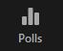
Polling
This tool is a way to keep students active in a session by prompting them with a question in a window that pops up in the Zoom session. Polls must be created by editing a meeting that has already been set up, although they can be created after a meeting has already started. Please note that the meeting must be scheduled to be able to add a poll. You can present multiple polls in a single meeting and include multiple questions in a single poll.
- This can be used to present a question or topic for discussion by asking students to respond, and then to discuss the perceptions and ideas after seeing the results.
- This is an effective virtual substitute for a clicker question, but students attending face-to-face can only answer the question if they are also logged in to Zoom.
- Polling can be anonymous or not, but it is not suitable for a graded quiz because it will not pass results back to the Canvas grade book. If you would like to have a graded quiz attached to a lecture, consider recording the lecture ahead of time with VidGrid and adding questions to the video.
- Currently, the polling feature only allows for multiple choice questions (students may select multiple answers or be limited to selecting a single answer).
- Here is a tutorial for setting up polls in a meeting: https://support.zoom.us/hc/en-us/articles/213756303-Polling-for-meetings

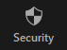
Security Features
Security can be a concern for any class, but the features available in Zoom help to make the virtual classroom safer for everyone when they are implemented properly. Consider the size of your class and the purpose of the Zoom meeting when implementing these functions.
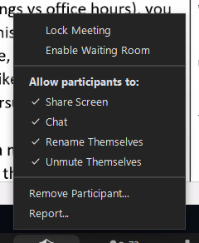
- From the Security button, you can choose how students may participate in the class, including turning off the chat, allowing or disallowing students to unmute themselves, and allowing or disallowing students to share their screens. You can also remove disruptive participants from here or the Participants panel.
- Use the waiting room to screen participants before they enter.
  - You can admit individual students or all students who are waiting from the waiting room using the Participants panel (see above, next to “Participants Panel”). You can also admit everyone by turning off the waiting room from the Security button.
  - This is a very useful feature for office hours held in Zoom, and allows students to have conversations about sensitive topics or information without anyone in the waiting room overhearing the conversation.
  - Please note that this is not a “traditional” waiting room where participants can see each other or who is in the main room, it is a space “outside” the Zoom room for them to wait on their own.
- You can set a password for an extra layer of security by choosing this setting when setting up the meeting. Please note that if you require a password but provide the “one-click” link to join, anyone with that link will be able to join, whether they are a student or not. Consider only providing the link through Canvas (where students must already be authenticated to access the session) or requiring registration for stronger security (requiring registration has the added benefit of seeing who signed in to Zoom for attendance purposes).
- More information about in-meeting Security features can be found here: https://support.zoom.us/hc/en-us/articles/360041848151-In-meeting-security-options

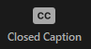
Captions
This button is reserved for live captioning for the meeting. Please note that this is not the same as a transcript that gets saved with a recording. If you have a student who needs an accommodation, please work directly with the office of Services for Students with Disabilities.

Final Suggestions
Zoom is a robust tool for online collaboration and communication, but it can be overwhelming at first. With some practice, these tools can work together to create an engaging, enriching experience for virtual students that mirrors and provides many of the same benefits of learning in a face-to-face classroom.
- Set up a time with some colleagues or friends specifically to test features of Zoom before trying them out in a high-pressure situation like a live class.
- Reach out to your Instructional Designer at the Center for Transformative Teaching for ideas and strategies for incorporating Zoom into your hybrid classroom.

