Zoom Basics Instructions
This document explains how to use Zoom through Canvas to help facilitate your courses. Note that these instructions assume that you will be using Zoom through Canvas and not through the Zoom website or app. If you need any help setting up or using your Zoom account outside of Canvas, please see this Zoom resource guide put together by UNL ITS.
This resource guide contains the following sections:
- Setting up Zoom in your Canvas course (p. 1-2)
- Setting up meetings (p. 2-3)
- Recording options (p. 3-5)
- Using Zoom chat (p. 5-6)
- Using Screen Sharing & Whiteboard functions (p. 6-8)
Important note for Mac users: The most recent security updates for the Safari browser can interfere with integrating Canvas and Zoom. We highly recommend that you use a browser other than Safari (either Google Chrome or Firefox work well). Similarly, a recent update to the Mac operating system sometimes interferes with functions within Zoom such as screen sharing. If you run into error messages about privacy / security settings, try following these steps:
- Go to “System Preferences” under the Apple Menu
- Click “Security and Privacy” (the icon is a grey house with a circle in the middle)
- Scroll to the bottom of the left sidebar to see “Screen Recording”
- Click on the grey box next to the Zoom icon (it is a check box that will turn blue when selected)
- You may need to quit and re-start Zoom if the application is open during this process

Screen sharing should then be enabled. If you still have trouble or want more information about this issue, please see this Help Resource from Zoom for more information.

Setting up Zoom in your Canvas course
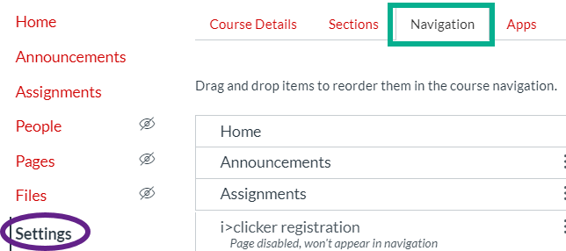
The easiest way to ensure your students can find the link to the Zoom meetings for your course is to set them up directly in Canvas.
- To get Zoom and Canvas integrated, go into the Canvas course you are working on.
- Click ‘Settings’ from the left side menu
- Click on the ‘Navigation’ tab at the top

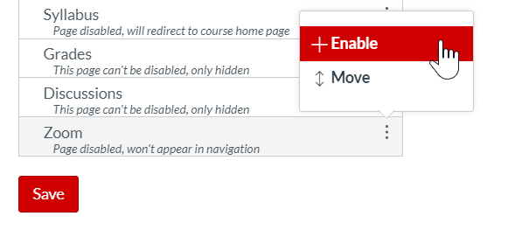
- Scroll down until you see the ‘Zoom’ option. Click on the 3 dots next to the ‘Zoom’ heading and select ‘Enable’. This will move Zoom up to the list of ‘Enabled’ features at the top of the Navigation page.
- Be sure to scroll back down to the bottom of the page and click ‘Save’ or Zoom will not actually be enabled!
- You will now see ‘Zoom’ listed in the left side navigation for your course.

Setting up Zoom Meetings
Now that Zoom is enabled for your course, you can set up meetings for your students.
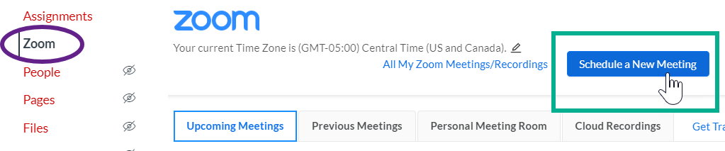
To schedule a meeting, click the ‘Zoom’ link from your left side navigation menu, then click ‘Schedule a New Meeting.

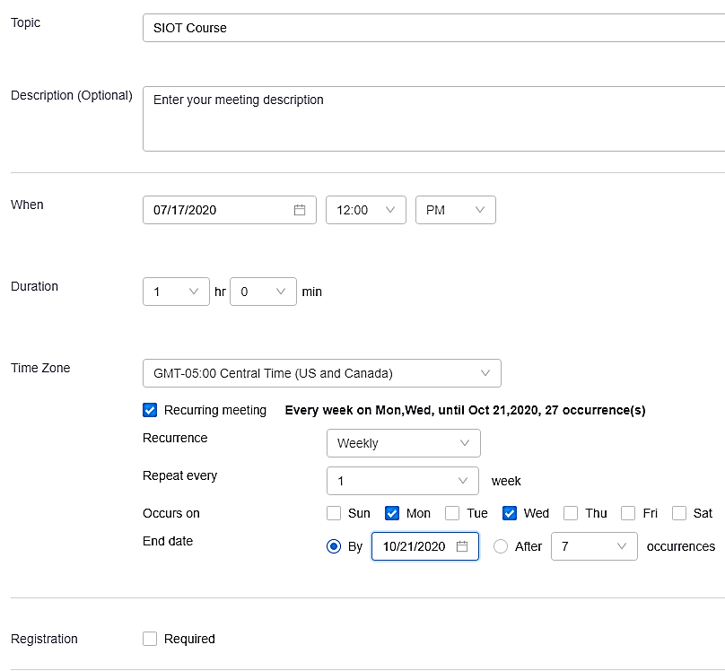
The dialogue box that opens will have a lot of different options for setting up your meeting.
- The topic will be automatically filled with the name of your course. If you will have different types of meetings for the course (Full course meetings vs office hours), you will want to add this information to the Topic. For example, you may want to call these something like ‘SIOT Course – class time meetings’ versus ‘SIOT Course – office hours’.
- You can also add a more detailed description below the Topic, but this won’t show on the main Zoom page for students.
- Fill in the time the first class meeting will take place, how long the meeting will last, and be sure the time zone is correct. If you are going to be meeting regularly (for example, every Monday & Wednesday), click the ‘Recurring Meeting’ button. Use the options to repeat the meeting as often as you need it to.
- Requiring registration will make all participants fill out a short form asking for their full name an email address before entering the meeting. This information may be useful for tracking attendance. This page has more information on viewing registration reports.

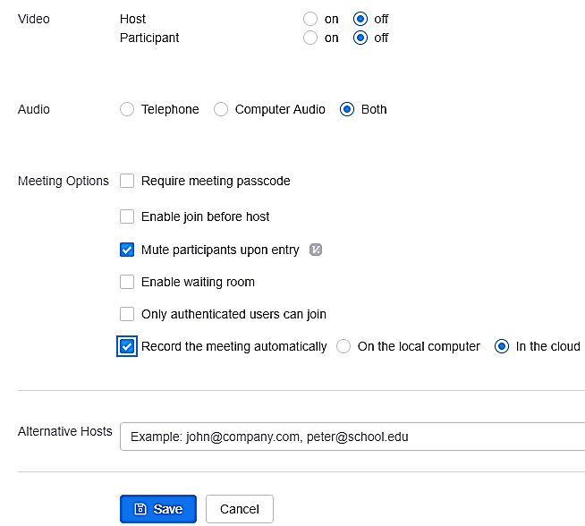
- We recommend leaving both of the ‘Video’ options to ‘Off’. This doesn’t mean that participants can’t use video, it just means that the video will be off when they initially join the meeting and they can manually turn it on when they’d like.
- Leave the Audio option at ‘Both’ so students can Zoom in using a phone call if they have low-quality internet.
- Requiring a Passcode can make things particularly confusing for students and isn’t necessary if you’re using Canvas integration, so we recommend not using this option
- If you want students to be able to chat before you get to the meeting, you can check the ‘enable join before host’ button
- Leave the ‘Mute participants upon entry’ checked. As with the video option above, students will be able to unmute themselves, but this will help prevent unnecessary background noise from students joining late.
- The waiting room adds extra security, but probably isn’t necessary for meetings organized through Canvas.
- Requiring authentication is less critical if they’re logging in through Canvas, but is a useful security feature.
- Setting the meeting up to record automatically is a nice feature if you’re prone to forgetting to start recording. We recommend using the ‘in the cloud’ option so that the recordings are available directly in Canvas. See the next section for more information on recording options.
- Alternative hosts have access to many of the control options as the host during a Zoom meeting. If you have a TA or someone that will be helping you facilitate the Zoom meeting, you will want to designate this person as an ‘Alternative host’.
- Be sure to click ‘Save’ when you have everything set up. And don’t worry – if you change your mind on options later, you can go back in and change them!

Recording Options

Recording to Cloud vs Local Computer
When you record a meeting, you have two different options for where to record it: On the local computer or In the cloud.
The ‘On the local computer’ option means that, when you end the meeting, the file will automatically download to your computer as an MP4 file. You will also get a .txt file that contains everything that was posted in the Chat during the recorded portion of the meeting. Note that when you record to your computer, this Chat file actually contains all chat files: both those posted publicly to the full group and those that were sent ‘privately’ between specific individuals. If you use this recording option, you will want to make sure you remind all participants that you will have access to those private chats. If you want to avoid this issue altogether, you can disable the ability to use private chats (for more information, see the next section on ‘Using Zoom Chat’.
The ‘In the cloud’ option means that, when you end the meeting, the recording will be saved to the University’s Zoom cloud server. If you are using Zoom through Canvas, when you use Cloud Recording, the video and chat files become quickly available to your students in Canvas. Note that only public chats sent to ‘Everyone’ will be available with Cloud recording. Cloud recording is definitely the better option if you are using Zoom through Canvas. Even if you aren’t using this integration, saving it to the Cloud can save you a ton of space on your computer, so it still might be the better option for you.

Starting and Stopping Recording during a Meeting
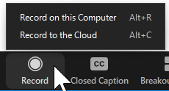
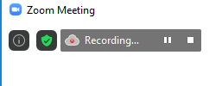
To record a meeting, you can either set the meeting to auto-record, as described in the Zoom Settings section above, or you can start the recording manually. If you have it set to record automatically, the recording will begin as soon as the first person enters the meeting room. If you have it set to record manually, you will need to click the ‘Record’ button at the bottom of the screen. You will then see the same Computer vs Cloud recording options that were discussed above.
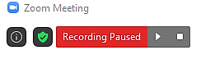
To tell if a meeting is currently being recorded, look at the top left of your screen. If you are the meeting host, you will see an icon that looks like this. You can then use the two buttons shown here to ‘Pause’ (left button) or ‘Stop’ (right button) the recording.
If you push the ‘Pause’ button, the icon will change to this one. The two buttons will now allow you to ‘Resume Recording’ (left button) or ‘Stop recording (right button).
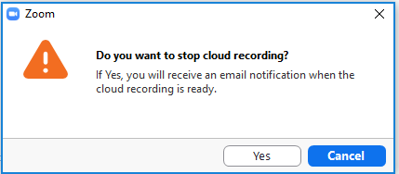
If you push ‘Stop Recording’ you will get this message. When you do this, Zoom will start the process or getting your recording ready for viewing. Note that if you end the meeting without stopping recording, Zoom will still render the recording and send you an email, you just won’t see this message to let you know that it’s happening.

Viewing your Recorded Meetings
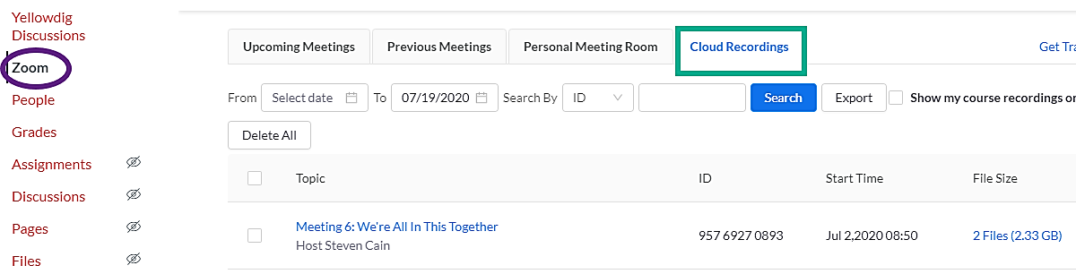
To find your Cloud recordings in Canvas, click Zoom from your left side navigation, then click on the ‘Cloud Recordings’ tab. Here, you will see a list of all of the recorded sessions for this course. If you want to find a specific meeting, you can use the ‘Date Range Filter’ or the ‘Search’ bar. Note that students can follow these same instructions to find the recordings for their courses.
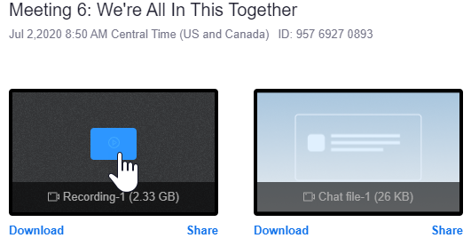
To view or edit a recording, just click on the name of the meeting. Here, you’ll see two files: The recording & the chat file. If you click the ‘Play’ button in the middle of the video recording, it will take you to a page where you can watch the video. You’ll notice that on the right side, there is a panel that has two headings: Audio Transcript and Chat Messages.

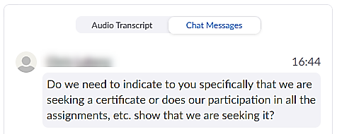
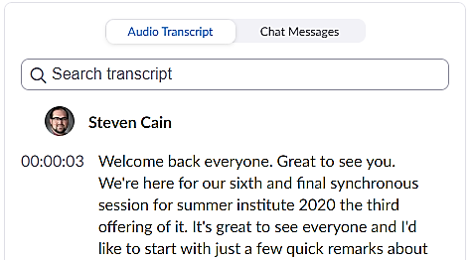
When you record to the cloud, Zoom automatically generates an audio transcript to go along with the video. Please note that these are machine captions that are not completely accurate. That means that they do not meet the requirements for ADA accommodations, so if you have a student that requires accommodations, you will need to upload the video to VidGrid and get professional captions for your video. If you don’t have a student requiring accommodations, using the auto transcript is usually fine. You may want to do some editing to ensure that things like field-specific vocabulary, acronyms, and names are spelled correctly. This document explains how to edit the transcript.
The other button, Chat Messages, shows the chat file that happened during the session. Unlike when you record to the local computer, cloud recording files only include public messages to ‘Everyone’, not any private messages between individual participants.

Using Zoom Chat
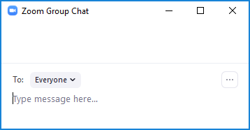
Zoom chat is a great way for participants to share resources and ask questions during a meeting.
To access the chat, click the ‘Chat’ icon at the bottom of the Zoom window. A little box like this one will pop up. If you click on the dropdown menu that says ‘Everyone’ you will see a list of participants. By clicking on one of them, you can send a private message to just that individual. To send you message, click in the ‘Type message here’ area, type your message, and hit ‘Enter’ to send.
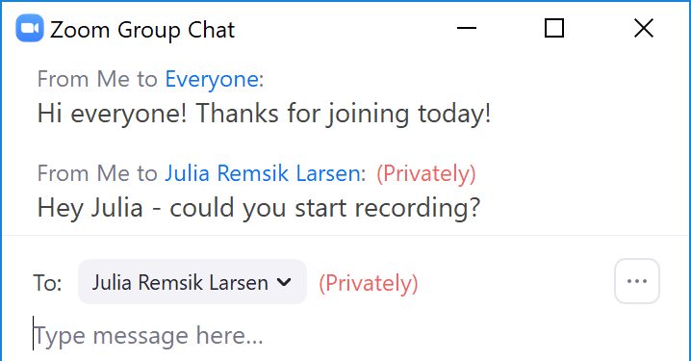
When chats are sent, they will appear like this in chronological order. You will see all of the chats you have access to in the same list: Both public ones labeled as ‘Everyone’ and private ones labeled with a specific person’s name.

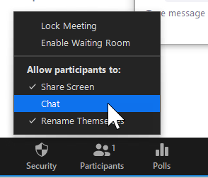
When hosting a meeting, you have a few different security options for the chat.
In some cases, you may want to completely turn off the chat because it is too distracting. To do that, click on the ‘Security’ icon at the bottom of your screen, and uncheck the ‘Chat’ option as shown here. When you do that, hosts and co-hosts will still be able to use the chat to send messages to the group, and the participants will still be able to see those messages. Participants will just be unable to send any messages either publicly or privately. In a class, we recommend against doing this, as you might make it impossible for students to contact you if something goes wrong.

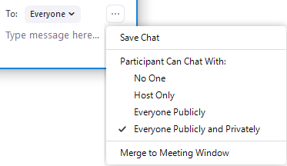
Instead of completely disabling the chat, you may want to use one of the other options available to limit the chat. To find those, click on the 3 dots on the bottom right side of the Chat window.
Make sure ‘Everyone’ is selected as ‘To’ so your changes affect all participants. The default setting is the last option where everyone can chat privately & publicly with everyone. To remove the private chat option, select the ‘Everyone Publicly’ button. If the public chat is getting a little overwhelming, choosing ‘Host only’ will make it so that your students can only send private messages to you and cannot publicly or privately message anyone else. Depending on whether you want students to be able to publicly ask questions and share useful resources or not, we recommend that you use either the ‘Host Only’ or ‘Everyone Publicly’ options.
Another handy option here in the Chat window is the ‘Save Chat’ button at the top. This option is available to all participants and hosts. It will save everything that has been publicly shared in the chat. If you are not recording the session but still want to have access to the ideas & resources that were shared, saving the chat at the end of each session is a great idea. If you are recording the session, those chats will automatically be saved & be available alongside the recording, as explained in the previous section.

Using Screen Sharing and Whiteboard Functions
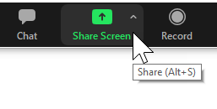
One incredibly useful feature for sharing information during a Zoom meeting is to share your screen with other people. This will allow you to do things like give a PowerPoint presentation that everyone in the meeting can see. To share your screen, start by clicking the green ‘Share Screen’ icon at the bottom of your Zoom window.
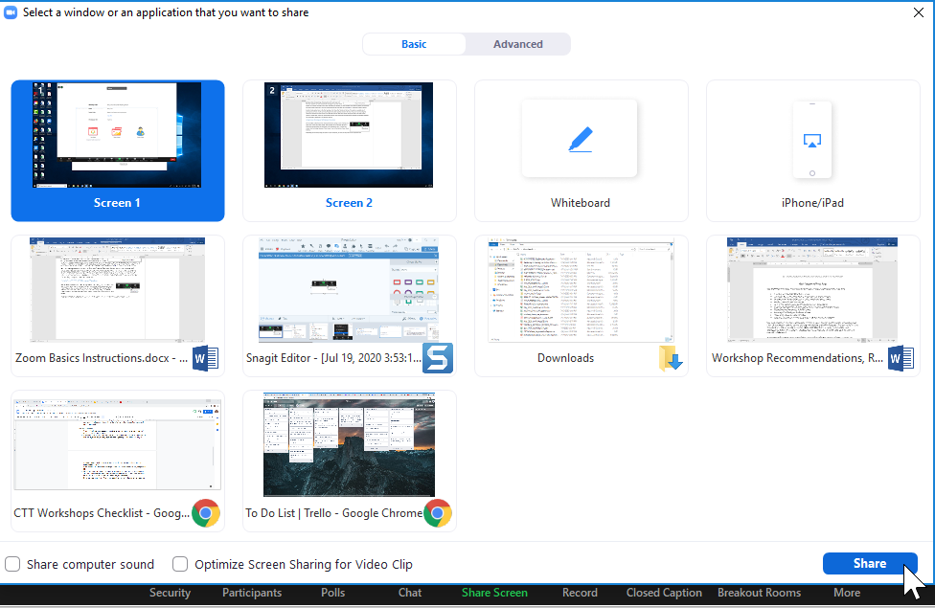
Depending on how many things are open on your computer, you may see very few or lots of options here. In my case, I’ve got lots of windows & files open, so I’ve got quite a few options. The first two are what I have showing on my two monitors. There are also a couple of word docs that I have open on my computer and some other internet windows that aren’t even showing on my monitors. You’ll need to sift through to find what you want to share, but normally it’ll be one of the first options if you’ve got it actively showing on your monitor. Once you’ve selected the right screen to share (highlighted in blue, like the top left screen here), click ‘Share’ at the bottom so everyone can see it.

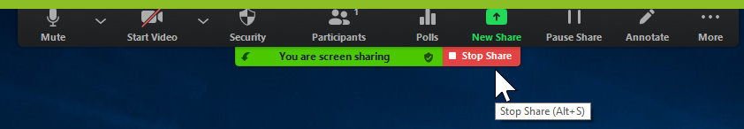
To see exactly what you’re sharing, there is a thick, green outline around the shared part of your screen. You can see part of that line on the top of this image. You’ll also notice that all of the options that used to be at the bottom of your screen have moved to the top, along with some new options.
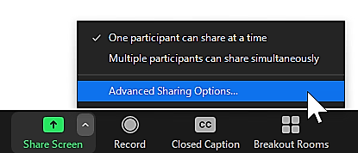
Clicking on the ‘New Share’ button will re-open the screen options box shown in the previous step. This is useful if you want to move back and forth between things that are on different monitors. The ‘Pause Share’ button will temporarily freeze the shared screen at whatever you are showing when you click Pause. You can then move things around on your screen, but participants will keep seeing the same thing. To stop sharing your screen completely, click the ‘Stop Share’ button.
During a meeting, you may or may not want other people to be able to share their screen. To adjust who can engage in screen sharing, click the little ‘Up Arrow’ next to the Screen share button when you’re not sharing your screen. Then select ‘Advanced Sharing Options’.

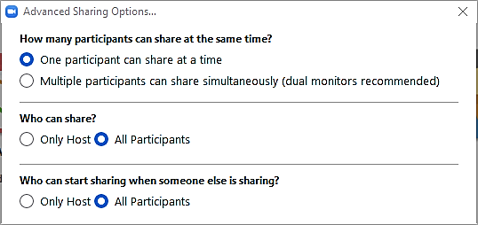
You will now see this dialogue box with different options available. It is highly recommended that you only allow one participant to share at a time.
To stop participants from sharing their screen, select ‘Only Host’ under ‘Who can share’.

Using the Zoom Whiteboard
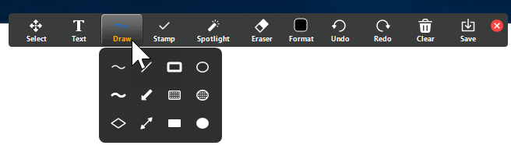
When you click on Share Screen, you may have noticed that there is a ‘White Board’ option. This will open a space where you can write & draw in an open space.
This picture shows the different drawing tools that are available. We won’t explain them all at length here, but if you are interested in learning more, see this website that explains the annotation tools in detail.

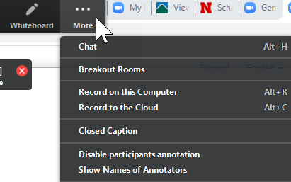
If you stop sharing the whiteboard & restart sharing later, it will save what you’ve done for you to continue drawing.
By default, all participants are able to annotate the ‘White Board’ when you start sharing it, which can be a fun collaborative experience. However, there may be times when you want to prevent participants from adding to the whiteboard space, click the ‘More’ button at the top right of the control panel, then select ‘Disable participants annotation’.
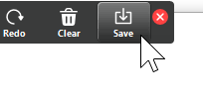
You can also have it show participant names next to their annotation to prevent anonymous mischief.
If you want to save what you’ve done on the whiteboard, you can click ‘Save’ from the top menu. This will save the file to your local computer as well as saving it to the cloud if you’re using cloud recording.
When participants are in breakout rooms, they have the ability to screen share and use the whiteboard, so this can be a useful space for small group activities in your class.
Controlling the whiteboard with your mouse can be a bit clunky, so you’ll have a nicer experience if you use a tablet with a smart pen instead of a mouse, track pad, or phone.

